The Shoebox Project MISSION:
“To share empathy, kindness and compassion with local women impacted by homelessness through the collection and distribution of gift-filled Shoeboxes and messages of support”.

A Shoebox gift is a powerful reminder for a woman that she has not been forgotten and that she remains a valued and respected member of her community.
It’s a small, simple gesture of kindness that has an immediate, positive impact on the woman who receives it.

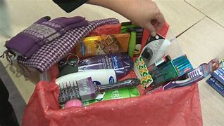
Each Shoebox is valued at approximately $50.
*Gift Card (we recommend $10 to a grocery or drug store)
*Shampoo & Conditioner (consider all hair types and textures)
*Body Wash
*Deodorant
*Toothbrush & Toothpaste
*wARM Socks
*Chocolate/Candy

The Shoebox Project is a tangible and creative opportunity to give back directly to someone in your very own community.

